# CS 255 System Design Document Template

## UML Diagrams

### UML Use Case Diagram

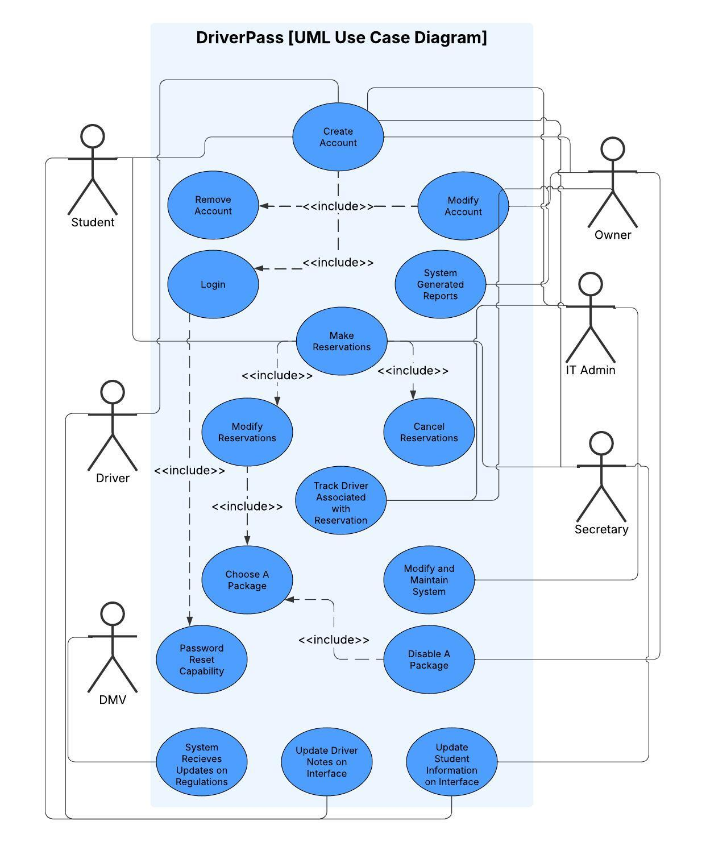

### UML Activity Diagrams

### UML Sequence Diagram

### UML Class Diagram

## Technical Requirements

*Hardware necessary for system design:*

*1. At least one fully operational computer capable of connecting to the Internet.*

*2. At least one fully operational Internet router with reliable Internet access.*

*3. At least one fully operational cell phone so that students may register with Secretary.*

*4. At least one fully operational printer to print out downloaded system generated reports.*

*5. Power cables necessary to connect computers, printer, phone and Internet router to electrical outlets.*

*Software necessary for system design:*

*1. At least one database application to store and access student information (including payment information) offline.*

*2. At least one database application, such as Microsoft Excel, to store and access the system generated reports offline.*

*3. At least one web browser application to securely connect computers to a web-based cloud service (system will be distributed in this way).*

*4. Conventional operating system, preferably the most up-to-date version of Windows.*

*5. Enable automatic system updates on Windows, so that all the necessary software stays secure and up to date.*

*Tools and Infrastructure necessary for system design:*

*The DriverPass online system is to be distributed to the public via a web-based cloud service, so therefore a subscription to a provider of this service, such as Google or Apple, will be necessary.*

*Aside from a suitable, physical location dedicated to storing and accessing the necessary electronic equipment such as those listed above, the system needs infrastructure in the form of the following staff members: Owner, IT Admin, Secretary, and Driver(s). The system needs vehicles necessary for on-the-road reservations, and at least one bank account dedicated to handling all of DriverPass's financial needs.*